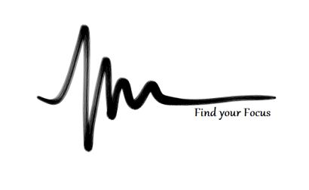
SheerMind Mindfulness Training
WEEK ONE

Introduction:
- Definitions – mind vs self
- Functions of the mind
- Your mind is a tool!
- Your ‘spotlight of attention’ must work for you, not against you

- When our minds run away from us
- Reactions / Distractions
- Moods
- Mind patterns

- Presence ... Consciousness... Mindfulness!

- How do we capture this?
- “Stepping out”
- Flame & Void

Why we’re doing this – where can we take this?

Intro to Presence:
- The Past, The Present & The Future
- What does each offer us?
- Which one is real?
- Practical & Philosophical benefits

- Why is the Present so powerful?
- Awareness
- Appreciation
- Using your mind as a tool
- Applying yourself to do-able challenges
- Release the burdens of the Past and Future
- You are able to become the Watcher of your mind

How do we get to Presence?
- Meditation
  - Long term clarity of mind
  - The base-layer of Presence
  - Methods

- Constant mental awareness
- Staying conscious, being the Watcher

Being Present is not a goal or an end point – the way we get there is Presence itself

First Practice – a look inside...
Meditation:

Sit up straight
Relax shoulders, arms, hands, legs etc
Breath normally
‘Follow’ breath
When thoughts arise, gently return to following breath

Homework:
- 1 x 10 Minute Meditation
- 1 – 3 Mindful Listening songs
- Try to be aware of your reactions, moods & mind patterns
Mindful Listening:
Choose a song
Pick out a sound; focus on that sound
When ready to move on, open awareness and choose another song
Use the flame & void if needed to end the initial thought

