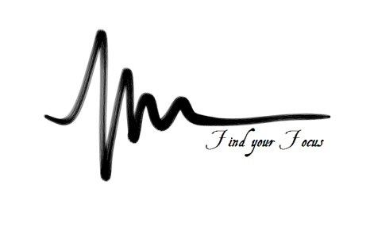
SHEERMIND MINDFULNESS TRAINING
PHASE TWO – EXPLORING MEDITATION SESSION 2

The Attitude of Meditation
-Approaching your meditation with the correct mindset is real meditation, beyond the physical-
- Idea of Mind – Spacious, flexible, powerful
- Lack of expectation – practice is perfect as it is, without results
- Having no ideals or goals – recognizing that practice is the end itself
- Immersion – bringing nothing in, leaving nothing behind
- Non-attachment to states of mind – separating from thought
- Lack of effort – empty-mind
Inviting qualities into your practice
- Dignity
- Calm
- Serenity
- Strength
Meditating on a single point other than the breath
- Flame
- Flower
- Picture
- Sound
- Quality
Ending your meditation
- Be gentle and ‘complete’ your meditation
- Have an end process, invite qualities or recite an affirmation
Understanding
- Transience (change) & Acceptance
- Limitless exploration through guidance of the mind

