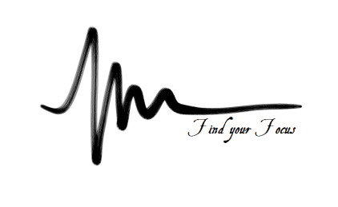
SHEERMIND MINDFULNESS TRAINING
PHASE TWO – EXPLORING MEDITATION SESSION 1

- Review of practice
- Type of meditation used
- Seated, single point meditation – Recap
- What are the benefits of single-point meditation?
- Distinction between Stillness and Insight
- Concentration
- Tranquillity
- Insight

The Physical Principles of Meditation
- Correct Posture
- Straight back
- Relaxed
- Breathing
- Releasing control – watching the breath
- Connecting with the Universe – where do you begin?
- No-thought
- Walking
- Mindful walking – conscious movement and Just Being
- Standing
- Tuning in to your body, feeling its movements and being still
- Mudras – What to do with your hands
- Cosmic Mudra – Relaxation, calm, gentle focus
- Openness – Palms up, receptive
- Closed energy circuit – Palms down, internal focus

- In these positions we are stronger, more ready to accept and adapt -
Practice:

