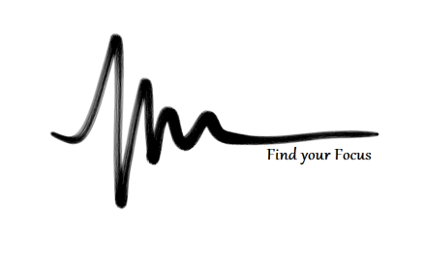
SHEERMIND MINDFULNESS TRAINING
PHASE TWO – ACTIVATING VISUALIZATION

- How have we used visualization before?
  - Single point focus (e.g. Flame)
  - Meditating on words/concepts/objects

What else does visualization have to offer? Why is it so important?
- Visualising is the most effective way to communicate vast amounts of information within yourself. Concepts, feelings, sensations, memory and imagination are all available when visualizing.
‘A picture tells a thousand words’ – Visualization is POWERFUL!

Passive Visualization
Passive visualizations are what we constantly create and live with – we create the world we live in, our self image and the events in our lives by projecting what we think.
- How are our thoughts related to visualizations?
- Where do these thoughts come from?
C________________________________________________________
P________________________________________________________
S________________________________________________________
What are some of your passive visualizations about yourself?
Positive: ___________________________________________________________________
Negative: __________________________________________________________________

- How would we go about changing the passive visualizations we have about ourselves if they seem to come from ‘nowhere’?
- By being Mindful of our thoughts and feelings, of course

Active Visualization
Active visualization is the conscious placement of images, feelings, sensations etc into your mind.
- Right from a single flame to a complete situation!
What are some of the benefits of active visualisation?
- Preparation for a specific situation
- Working through a difficult emotion
- Disempowering a stressful memory
- Developing/furthering ideas
- Communicating with your subconscious mind
- Making positive changes to your passive visualization system

Learning to engage active visualization
WARNING – this process takes a long, long time. Do not expect results immediately. Move at your own pace and take each step with absolute effort and concentration.
- Holding an image
- Manipulating an image
- Adding elements to the scene
- Creating a full sensory experience

One way to help your concentration (and sidestep some of the finer points of visualization) is to visualize in ‘story form’.

Going to your room

Standing on top of a building, take an elevator down 7 floors, breathing once each floor. Exit the elevator and turn right. Open a door and take seven steps down, breathing every step. Summon a ‘guard’ to take you down the corridor to your room. Speak with your guard, ask him or her questions and see what occurs. Perhaps the guard is yourself as you’d like to be? As you reach the door to your room, ask your guard to take care of you. Enter your room – this is your private area of calm, serenity, strength... it is anything you want it to be. Here, you can think, meditate, relax or even sleep. It helps to begin a visualization with a story form so that your mind plays along. Once you are here, your focus will be keen and you can proceed as you wish. If you are feeling up to it, reverse the process when you are done – addressing your guard, climbing the stairs and leaving via the elevator, returning into the world.

